

PROJECT SYNOPSIS SEMESTER: VI

PROJECT GROUP NO: 41 ACADEMIC YEAR: 2026-27
A. Proposed Title of the Project
Originality check with intelligent student project management system
B. Introduction
In academic institutions, student projects form an essential component of the curriculum, allowing students to apply their theoretical knowledge to practical problem-solving. However, the current project management process faces multiple challenges:
Many challenges exist in student project management, such as the repetition of ideas where students unknowingly propose projects that already exist, leading to reduced innovation and redundant work. Supervisor allocation is another issue, as the manual process often causes mismatches of expertise, workload imbalance, and unfair distribution. Furthermore, progress monitoring is inconsistent, with some students contributing actively while others do very little, making it difficult to track overall involvement. As a result, evaluation becomes challenging and often biased, since supervisors lack proper evidence of each student’s contribution throughout the project lifecycle.
To address these issues, this project proposes the development of an AI-powered web-based system that integrates three major functions:
Novelty Detection: Uses Machine learning to check originality of project ideas and provide improvement suggestions. Intelligent Supervisor Allocation: Matches students/teams to supervisors based on existing ideas.
Progress Tracking & Evaluation: Provides structured weekly task allocation, submission, and monitoring so that supervisors can evaluate both team performance and individual contributions and the plagiarism checking.
The system ensures efficiency, fairness, and transparency in academic project management. It not only assists students in developing original projects but also helps supervisors manage multiple teams effectively.

The system incorporates to enhance accuracy and effectiveness. Instead of relying only on keyword matching, the system performs concept-based matching, which allows it to understand the actual meaning of project ideas and identify similarities more accurately. It also handles variations in terminology, such as “AI” and “Artificial Intelligence,” by normalizing them into a common representation, thereby reducing errors caused by different naming styles or spelling differences. The supervisor allocation process is further improved by considering both domain expertise and the similarity of project ideas, ensuring better matching along with fair workload distribution among faculty members. Furthermore, the system extends its functionality to include report-level plagiarism checking in addition to idea-level originality detection, maintaining integrity in both project proposals and final submissions. When a project shows high similarity, the system provides suggestions for improvement, enabling students to refine their ideas rather than rejecting them outright. These enhancements improve the overall accuracy of originality evaluation and strengthen the integration of all modules within a single, efficient workflow.

C. Literature Review
Student project management in academic institutions involves multiple processes such as supervisor allocation, originality checking, task monitoring, and performance evaluation. Although several studies have addressed these challenges individually, there is still a lack of a unified system that combines all these functions into a single platform. Existing research mainly focuses on one specific area, such as allocation, plagiarism detection, or project tracking, without providing a complete workflow for academic project management. Our proposed system aims to overcome these limitations by integrating originality detection, intelligent supervisor allocation, plagiarism checking, and continuous progress monitoring into one efficient platform.

Several researchers have focused on the problem of supervisor allocation in academic projects. Salami and Mamman (2016)proposed a genetic algorithm model for allocating supervisors to students by optimizing workload balancing and matching project domains with faculty expertise. Similarly, Chown et al. (2018) used simulated annealing techniques for student–project allocation, while Abraham et al. (2004) introduced theoretical allocation algorithms for fair matching. These studies improve the efficiency of allocation but do not address originality checking, plagiarism detection, or project monitoring after allocation. In contrast, our system not only performs intelligent supervisor matching but also supports project originality validation and tracking of progress throughout the project lifecycle.

Another important area of research is originality and novelty detection. Ghosal et al. (2022) reviewed novelty detection techniques in natural language processing and emphasized the importance of identifying unique ideas. Liu et al. (2025) explored the use of large language models for scientific novelty detection by comparing semantic similarity with existing work. Tesma (2018) also proposed AI-based novelty detection in crowdsourced idea spaces to identify innovative contributions. These studies demonstrate the importance of novelty detection but focus mainly on idea-level originality and do not include other project management features. Our project extends these ideas by integrating originality checking with intelligent supervisor allocation and continuous evaluation of project progress.

Research in plagiarism detection has also gained importance in recent years. Alzahrani et al. (2012) discussed various plagiarism detection techniques in academic writing, while Amirzhanov et al. (2025) and Sajid et al. (2025) studied modern AI-based plagiarism detection methods for identifying copied, paraphrased, and AI-generated content. Setu et al. (2025) proposed a cost-effective plagiarism detection system for educational institutions, and Shikha et al. (2024) introduced an NLP-based plagiarism detection approach using semantic and syntactic analysis. Although these studies improve plagiarism detection accuracy, they are limited to detecting copied content and do not provide project allocation or monitoring capabilities. Our system incorporates plagiarism checking along with originality detection, faculty matching, and structured workflow management.

Semantic similarity techniques have further improved the ability to compare project ideas beyond simple keyword matching. Ihnaini et al. (2024) presented a survey on semantic similarity methods, while Gao et al. (2025) proposed transformer-based frameworks for text similarity analysis. Lieharyani et al. (2025) studied the role of semantic similarity in academic plagiarism detection and highlighted the importance of combining lexical and contextual analysis. These approaches are useful because they allow the system to recognize that terms like “AI” and “Artificial Intelligence” have the same meaning. Our proposed system uses similar semantic techniques to improve novelty detection, handle spelling variations, and provide more accurate similarity results.

Project tracking and evaluation are equally important in academic project management. Ohal et al. (2020) developed a project tracking system to monitor deadlines and progress, while Soms et al. (2021) proposed a student project management system for handling submissions and records. Fachrizal et al. (2020) created a web-based project management system for construction projects. These systems support scheduling and monitoring but do not include originality detection or intelligent supervisor allocation. Our project combines all these features into a single workflow where projects are first checked for originality, then allocated to suitable supervisors, and finally monitored through weekly tasks, submissions, feedback, and evaluation.

Overall, the literature shows that existing systems generally focus on individual functionalities such as novelty
detection, plagiarism checking, supervisor allocation, or progress monitoring. There is still a gap in developing a complete academic project management system that integrates all these features together. The proposed system

addresses this gap by combining semantic originality detection, intelligent supervisor allocation, plagiarism checking, and continuous progress tracking into a single platform.

.
D. Objectives
- To develop a system that checks the novelty and originality of student project ideas.
- To implement an intelligent supervisor allocation mechanism based on domain expertise.
- To provide AI-driven suggestions for improving project novelty.
- To build a structured review and approval workflow for supervisors.
- To integrate a progress tracking module for weekly task allocation, submissions, and monitoring.
- To enable fair evaluation of individual contributions within a team.
- To check the plagiarism of the project
E. Workplace |  | Address of Other Institute / Industry (if any):
Shri Madhwa Vadiraja Institute of Technology and Management |  | Vishwothama Nagar, Bantakal, Karnataka 574115
F. Requirement Details
1. Hardware | A system with Internet connectivity
2. Software | HTML,CSS,JavaScript,Python(Flask,Transformers,Scikit-learn,SpaCy),VS Code
3. Skill sets | Programming (Python, JavaScript)  Web development (React/HTML/CSS/JS) Backend frameworks (Flask)  Database handling Machine Learning
4. Others

G. Figure(s)/Drawing(s)

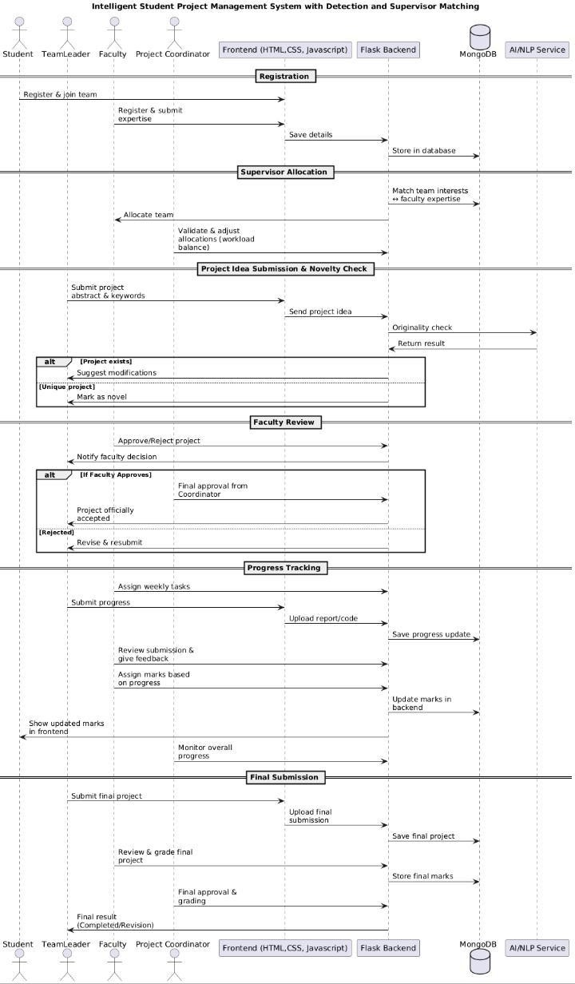
H. Methodology
Step 1: Requirement Analysis
Identify stakeholders (students, supervisors, admin).
Collect requirements such as originality check, supervisor allocation, task tracking, and evaluation.
Step 2: System Design
Design the database schema (student, teacher, project, task, marks). Create UI/UX wireframes for student and teacher dashboards.
Develop workflow diagrams.
Step 3: Module Development
Module 1: Student Team Registration & Interest Submission Students register and form teams.
Each team submits at least 4 areas of interest.
Module 2: Supervisor Registration & Expertise Submission Supervisors register and submit at least 4 areas of expertise.
Module 3: Supervisor Allocation Algorithm
System compares student interests with teacher expertise.
Allocates guide based on maximum interest similarity + workload balancing.
Module 4: Project Idea Submission & Novelty Check

Team submits project abstract and keywords.
AI-based system checks originality using semantic similarity search. Provides suggestions for low-novelty ideas.
Module 5: Dual Approval & Progress Tracking
Both system (AI originality check) and supervisor, project coordinator must approve the project. After approval → supervisor assigns weekly tasks with deadlines.
Students upload weekly progress (documents, code, reports).
System tracks submissions as On-time / Late / Pending/meeting with the supervisor. Supervisor reviews progress, gives feedback, and awards partial marks.
Based on the feedback, system automatically grades the student performance and notifies to the team members.
Module 6: Evaluation & Leaderboard
Individual contribution is calculated (who submitted what). Marks are assigned for both individual and team performance. Final performance analysis of team based on grades
Leaderboard can display top-performing students/teams (future extension).
Step 4: Integration & Testing
Combine frontend, backend, database, and AI modules. Perform functional testing, load testing, and validation. Step 5: Deployment
Deploy as a web application (local server).

I. Flowchart (Plan of Action)
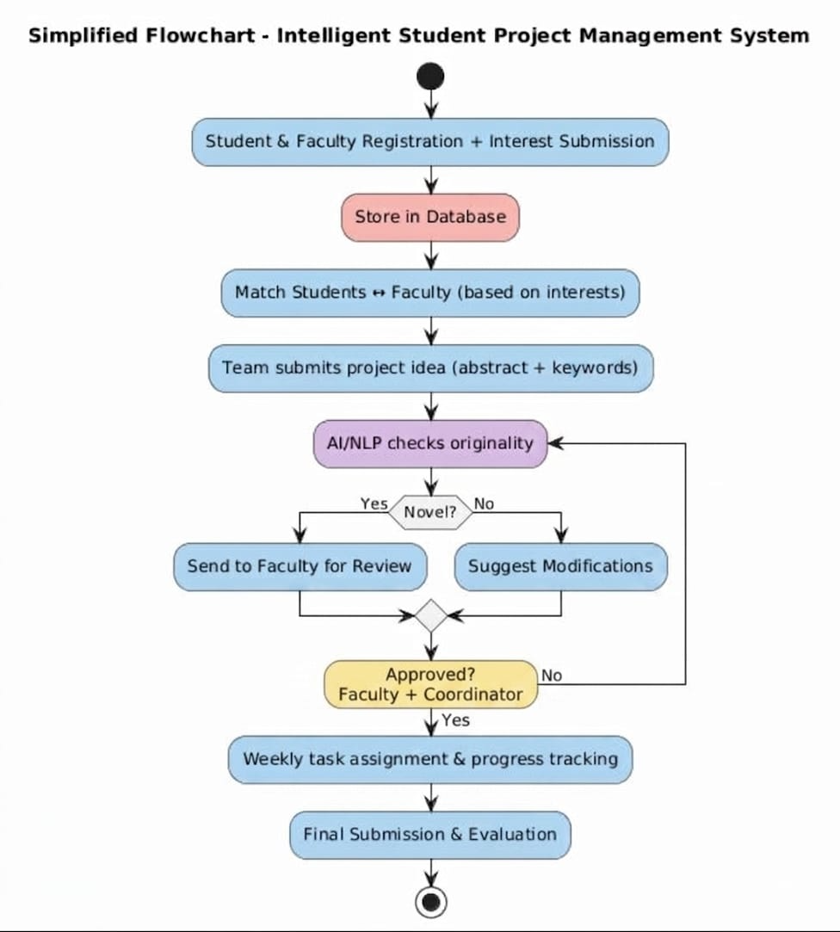
J. Expected Outcome of the project
1.A functional web application for student project originality checking, supervisor allocation, and progress monitoring. 2.Automated novelty detection system powered by ML models.
Improved supervisor–student matching, reducing manual allocation effort. 3.Supervisor dashboard with project approval, task allocation, and feedback features.
- Progress tracking module for weekly submissions and fair evaluation of students.
- Scalable design that can evolve into a major project management platform with leaderboards

K. Estimated cost | Source of Fund

L. References (IEEE Format)
- Salami, O. S., & Mamman, A. (2016). A Genetic Algorithm for Allocating Project Supervisors to Students. International Journal of Intelligent Systems and Applications (IJISA), 8(10), 59–66.

- Liu, C., et al. (2025). Harnessing Large Language Models for Scientific Novelty Detection. arXiv preprint arXiv:2501.12345.

- Ghosal, D., et al. (2022). Novelty Detection: A Perspective from Natural Language Processing. ACL Anthology.

- Chown, A. H., Cook, C. J., & Wilding, N. B. (2018). A Simulated Annealing Approach to the Student–Project Allocation Problem. arXiv:1404.4679v2.

- Akoglu, L., Tong, H., & Koutra, D. (2015). Graph-Based Anomaly Detection and Description: A Survey. ACM Computing Surveys, 48(1), 1–42.

- Alzahrani, S. M., Salim, N., & Abraham, A. (2012). Understanding Plagiarism Detection Techniques. IEEE Transactions on Systems, Man, and Cybernetics, Part C, 42(2), 172–182.

- Tesma, A. (2018). AI-Based Novelty Detection in Crowdsourced Idea Spaces. IJEAST, 2(8), 132–139.

- Fachrizal, M. R., Wibawa, J. C., & Afifah, Z. (2020). Web-Based Project Management Information System in Construction Projects. IOP Conference Series: Materials Science and Engineering, 879, 012064.

- Ohal, S., et al. (2020). Project Tracking System. International Research Journal of Engineering and Technology (IRJET), 7(5), 5615–5620.

- Soms, N., Prashanth, S., Preethika, P., & Kumar, D. D. (2021). Student Project Management System. International Journal of All Research Education and Scientific Methods, 9(3), 1293–1303.

- Amirzhanov, A., et al. (2025). Artificial Intelligence-Based Approaches for Plagiarism Detection: A Systematic Review. Frontiers in Computer Science, 7, 1504725.

- Sajid, M., et al. (2025). A Comparative Study of Modern Plagiarism Detection Techniques for AI-Generated and Human-Written Text. IEEE Access, 13, 34567–34580.

- Setu, S., et al. (2025). A Cost-Effective Plagiarism Detection System for Academic Institutions. International Journal of Educational Technology in Higher Education, 22(1), 45–60.

- Ihnaini, B., et al. (2024). Semantic Similarity Methods in Multimodal Data: A Comprehensive Survey. Journal of King Saud University – Computer and Information Sciences, 36(2), 101234.

- Shikha, R., et al. (2024). NLP-Based Plagiarism Detection Using Semantic and Syntactic Analysis. International Journal of Machine Learning and Applications, 13(4), 55–63.

- Gao, T., et al. (2025). Transformer-Based Framework for Semantic Similarity Analysis in Text. arXiv preprint arXiv:2501.14288.

- Lieharyani, P., et al. (2025). The Context Similarity Problem in Academic Plagiarism Detection. International Journal of Advanced Computer Science and Applications, 16(1), 210–218.

- Sharma, K., et al. (2025). Integrated AI-Based Plagiarism Detection System Using Deep Learning Techniques.
Journal of Information Systems Engineering and Management, 10(2), 3886–3895.

- Verma, R., et al. (2025). A Framework for Online Academic Project Evaluation Using Artificial Intelligence.
International Journal for Research in Applied Science and Engineering Technology (IJRASET), 13(2), 498–505.

- Toker, S., & Akgun, O. (2024). Artificial Intelligence, Plagiarism, and Academic Integrity: The Role of Task Complexity. arXiv preprint arXiv:2412.13412.
M. SDG Mapped
SDG 4: Quality Education,lThe system promotes academic integrity, encourages original research, enables transparent and fair evaluation, and strengthens collaboration between learners and mentors

SDG Target 4.4: emphasizes equipping individuals with relevant technical and professional competencies required for innovation, employment, and lifelong learning
N. Project Batch members
S.No. | USN | Name |  | Signature with date
1. | 4MW23CS104 | Prithesh R Shetty
2. | 4MW23CS098 | Prashanth Kulal
3. | 4MW23CS092 | Poorvik
4. | 4MW23CS096 | Prakhyath Nayak
O. Accepted/Rejected:
P. Suggestions for implementation:
Q. Guidance & Review Panel
Guide (s) allotted |  |  | Name and Signature (s) with date
- Guide  - Reviewer 1  - Reviewer 2  - Reviewer 3 |  |  | Ms. Tejaswini H

